# Department of Computing

# 

**CS110: Fundamentals of Computer Programming**

**Lab 01: Introduction of Python and IDLE (Integrated Development Environment)**

**CLO1: Understand the syntax and semantics of different programming constructs**

**Student Solutions**

**Instructor: Mr. Jaudat Mamoon**

**Lab Engineer: Mr. Danyal Sadiq**

## Hamza Hamid

## Best 10/10

## Lab 1: Introduction of Python and IDLE

### Introduction

This lab is designed to develop basic understanding with python and its development environment IDLE.

### Objectives

The objective of this exercise is to become familiar with the Python IDE for version 3.x while introducing basic mathematical operations, variable types, and printing options.

### Tools/Software Requirement

Python IDLE

### Description

#### Installation:

Download the Python 3.x from this link: <https://www.python.org/downloads/>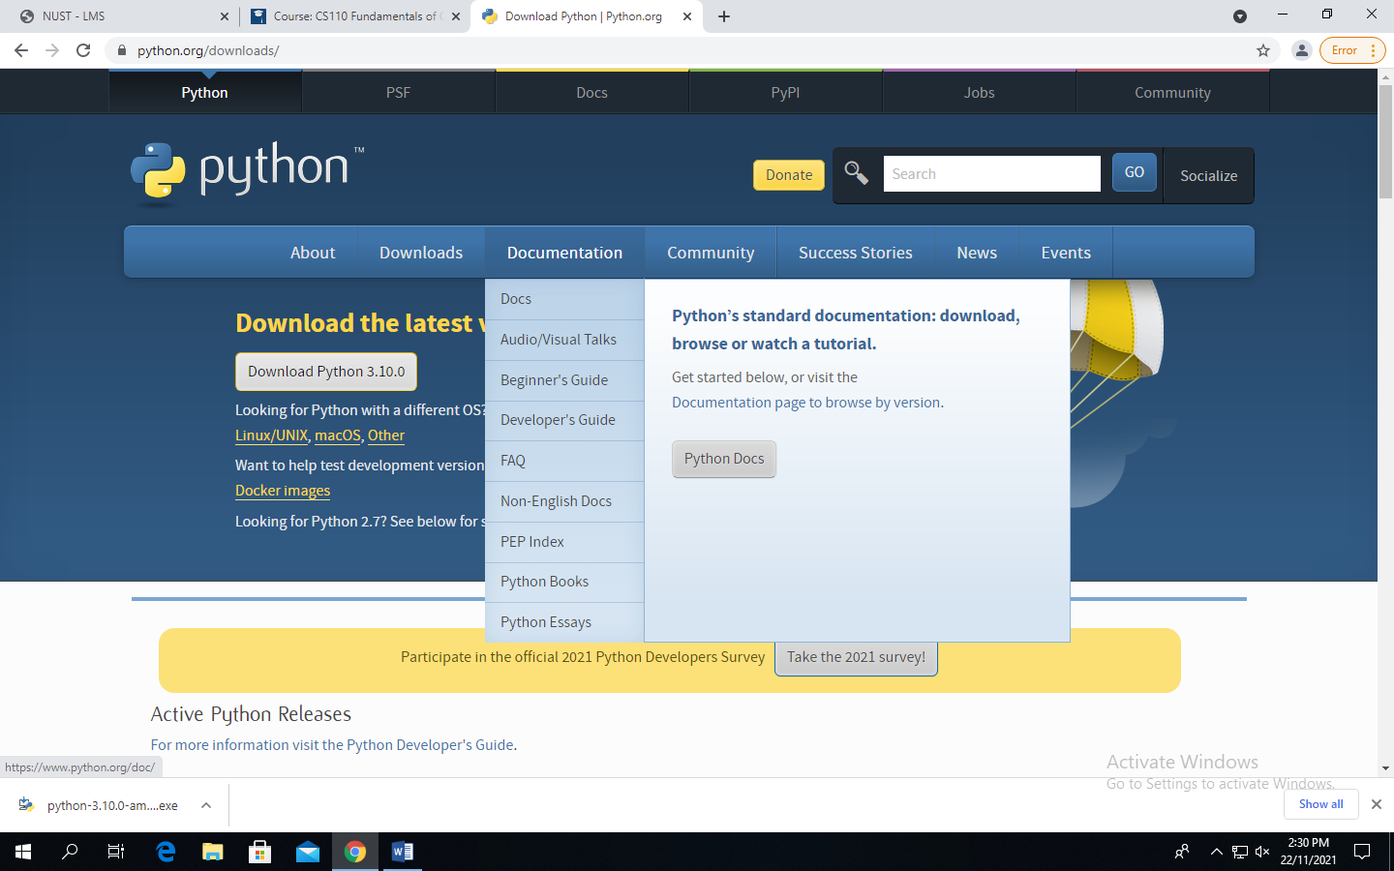

[1 Mark]

Once downloaded, double click on the .exe file downloaded and run the installation procedure.

You can select the IDLE (Python), by pressing windows key, and type IDLE, select IDLE (Python).

|  |
| --- |
|  |

#### Introduction to Python:

Python is a widely used [high-level programming language](https://en.wikipedia.org/wiki/High-level_programming_language) used for [general-purpose programming](https://en.wikipedia.org/wiki/General-purpose_programming_language), created by Dutch [programmer](https://en.wikipedia.org/wiki/Programmer) [Guido van Rossum](https://en.wikipedia.org/wiki/Guido_van_Rossum) and first released in 1991. Its syntax allows programmers to express concepts in fewer [lines of code](https://en.wikipedia.org/wiki/Source_lines_of_code) than possible in languages such as [C++](https://en.wikipedia.org/wiki/C%2B%2B) or [Java](https://en.wikipedia.org/wiki/Java_%28programming_language%29).

Virtually all modern programming languages make use of an IDE, or Integrated Development Environment, which allows the creation, editing, testing, and saving of programs and modules. In Python, the IDE is called IDLE (like many items in the language, this is a reference to the British comedy group Monty Python, and in this case, one of its members, Eric Idle).

**Interactive Mode vs. Scripted Mode**

Python can be run in one of two modes. It can either be used interactively as explained above, via an interpreter, or it can be called from the command line/Scripted Mode to execute a script.

### To Open Python in Scripted Mode

1. Open IDLE

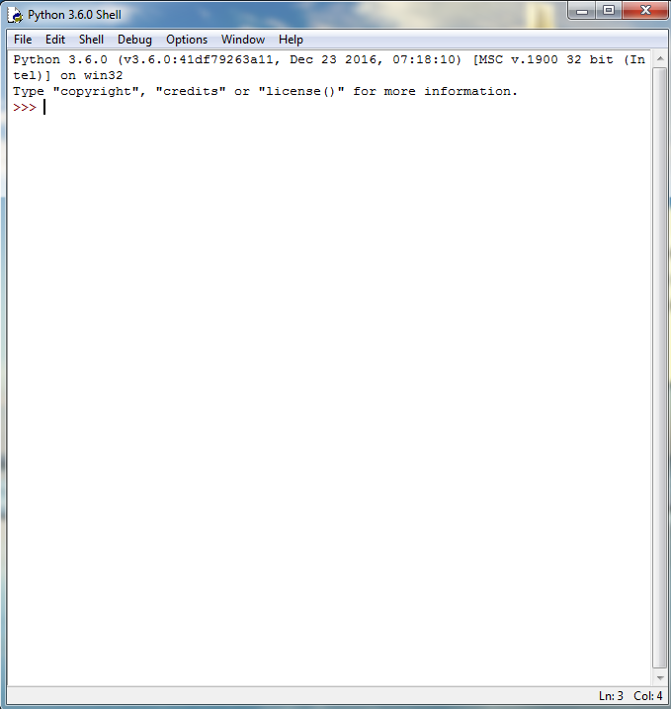

1. Go to *File* >> *New File*

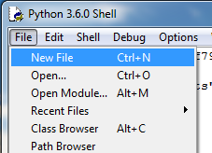

1. Enter your code

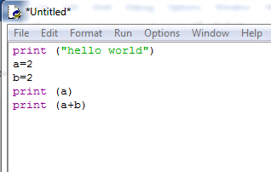

1. Save the file on your desired location

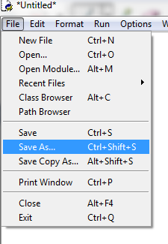

1. Either save the file by selecting *Python files* from *Save as type*

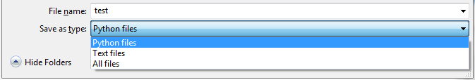

OR explicitly define the type of file by writing *.py* extension at the end of the name

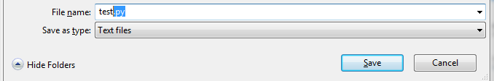

1. See the name of the file has been changed with the *.py* extension



1. Now Go to *Run* >> *Run Module* OR enter *F5* on your keyboard to run the code in Scripted Mode

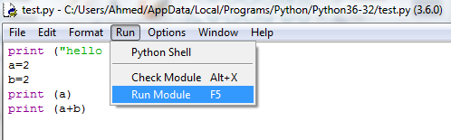

1. See the output

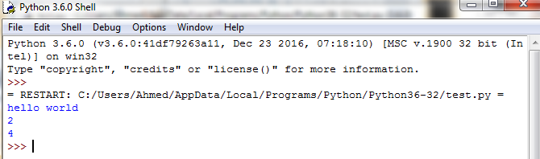

#### Lab Tasks:

1. **TASK 1**

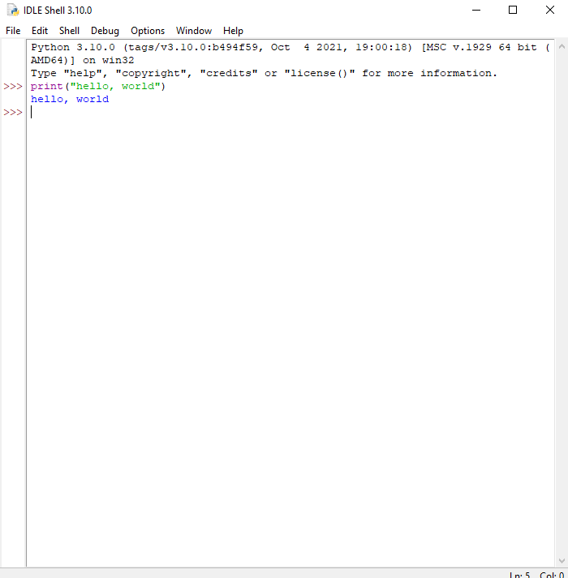

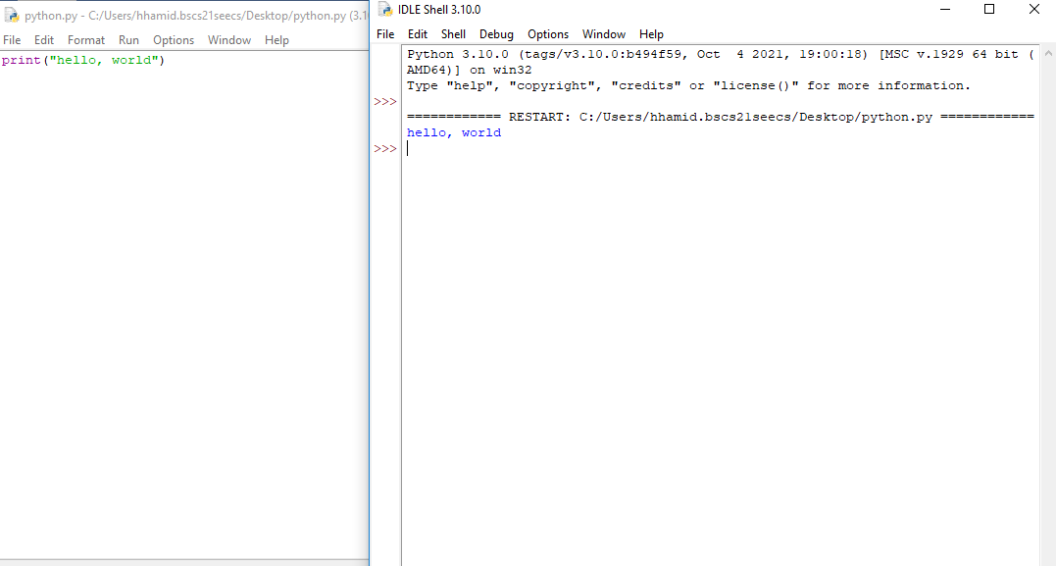

1. **TASK 2**

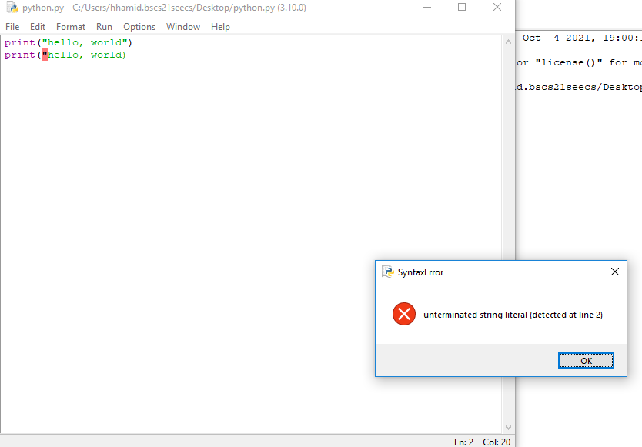

1. **Task 3**

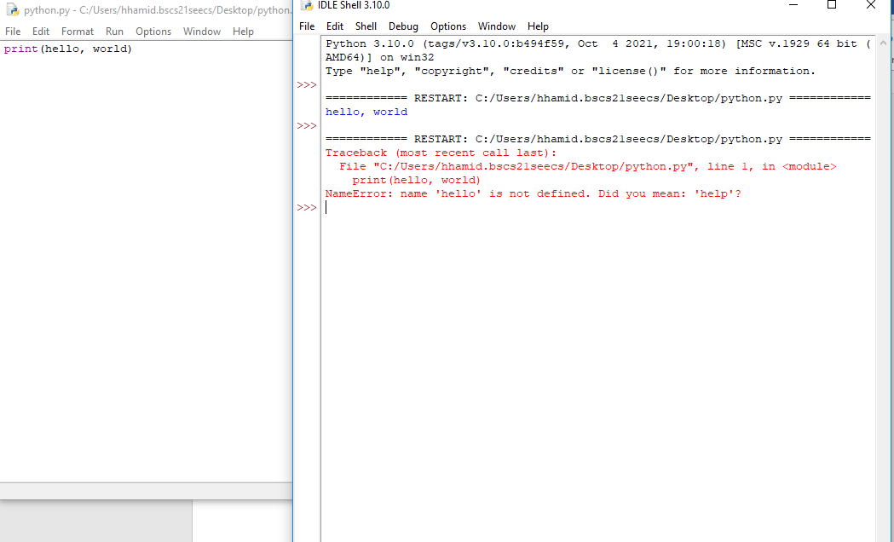

1. **TASK 4**

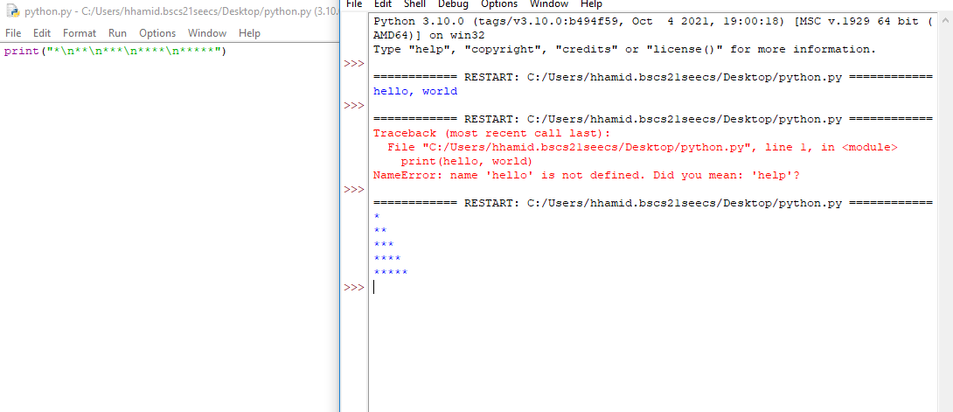

1. **Task 5**
2. 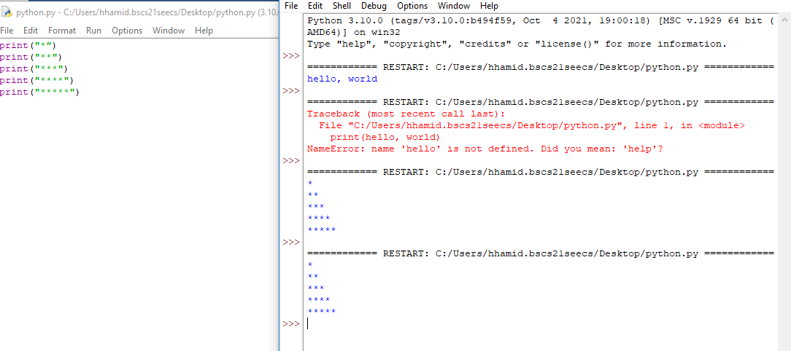

**Muhammad Zain Jee**

**Average 9/10**

**Task 1) Install Python**Python Version 3.10 has been installed. **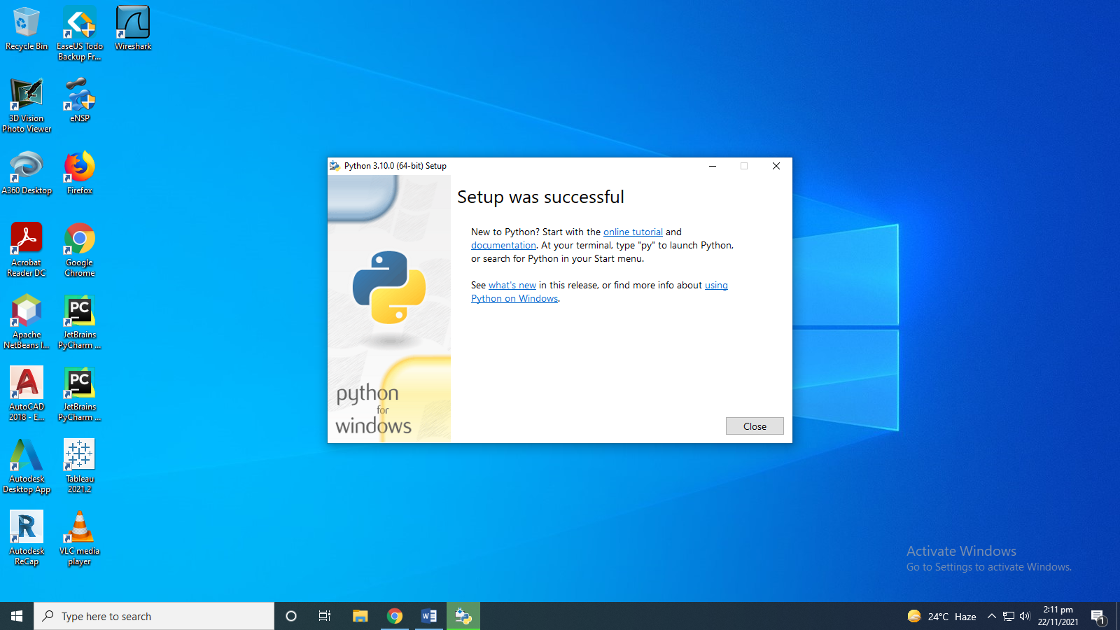  
  
Task 2) Open Python IDLE**

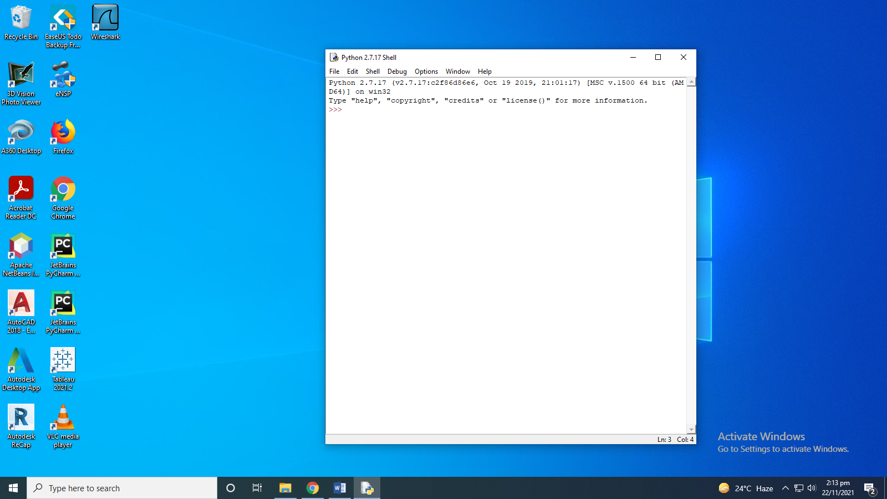

**Task 3) Write a program in both scripting and interactive mode, that prints on screen the message Hello, World.**

1. **Hello World in Interactive Mode.**

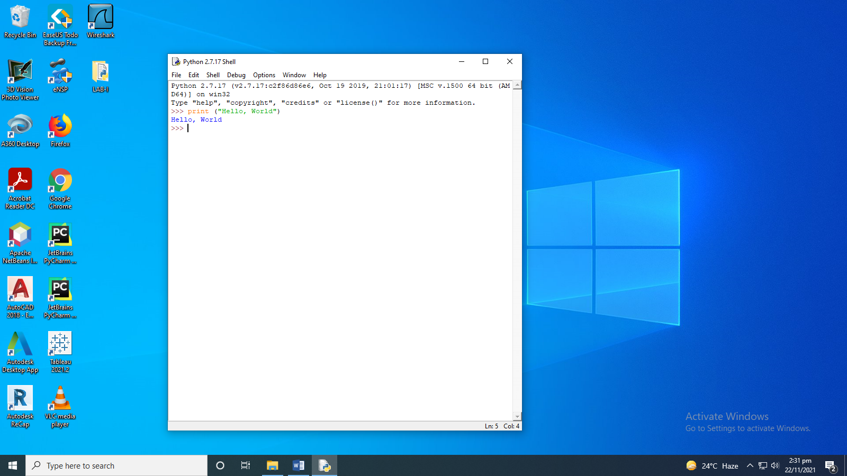

**b)Hello World In Scripting Mode**

The code for ‘Hello World’ in Scripting Mode is as follows.

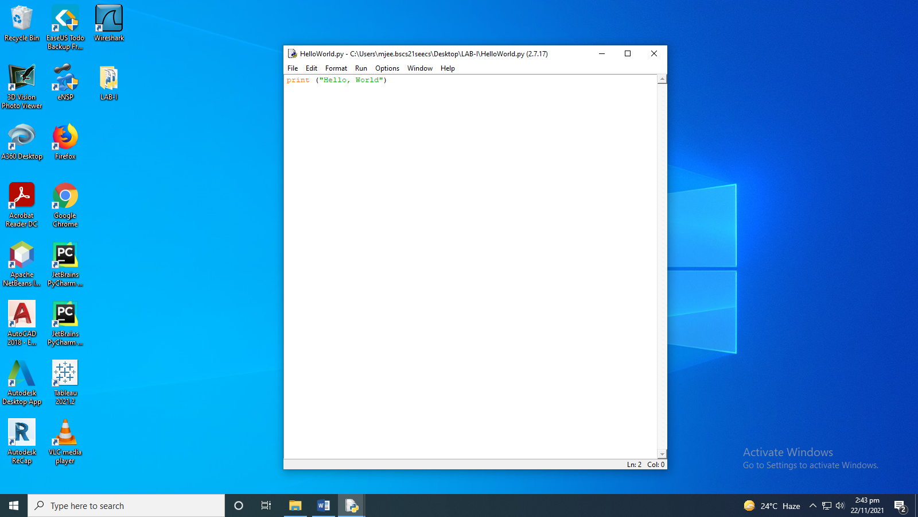

The Execution of ‘Hello World’ in Scripting Mode is as follows

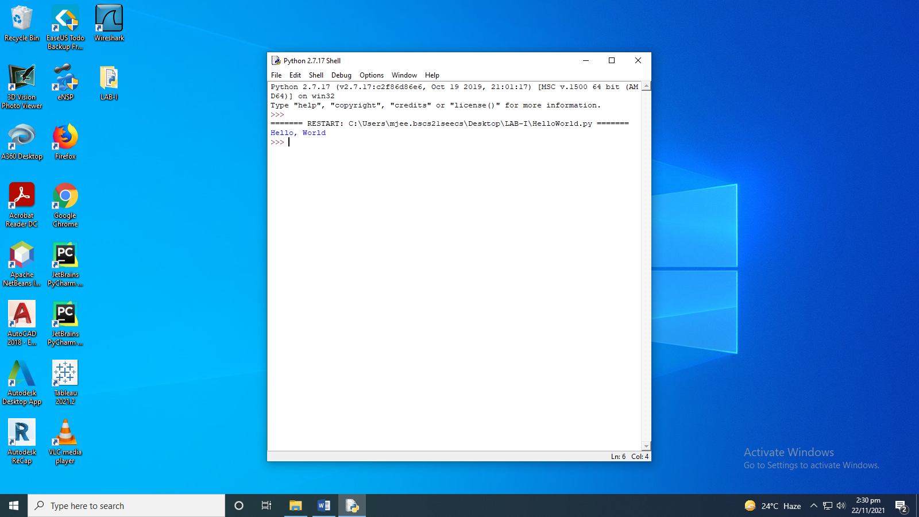

**Task 4) Using the program in (1), what happens if we remove the closing quotation around the text Hello, World?**

Now, we will remove a single inverted comma, from the source code shown above. The code is as follows. 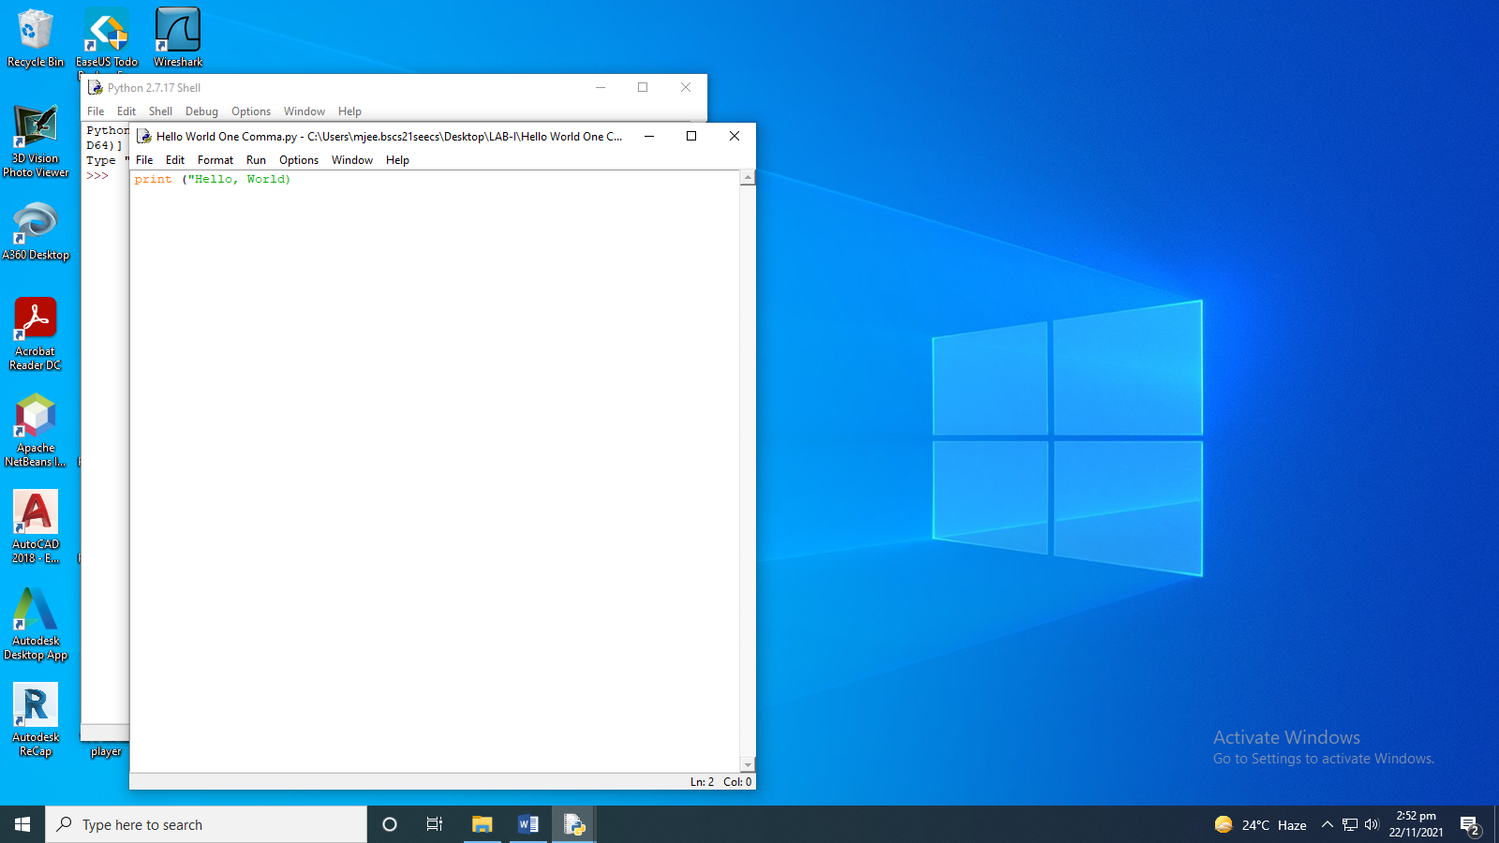

The Execution of Hello Word with one inverted comma is as follows. It gives us an error named ‘EOL while scanning literal string’ 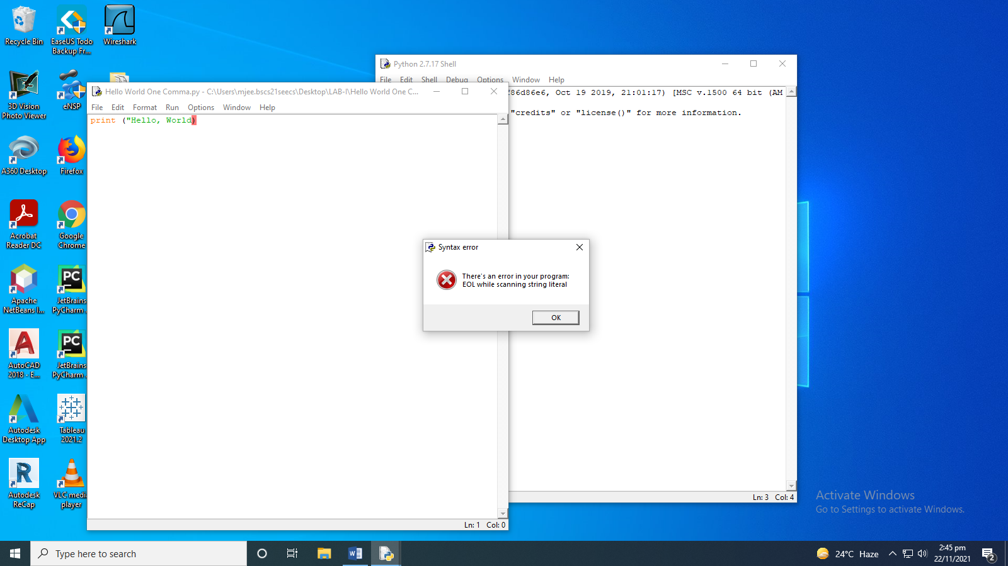

**Task 5) Using the program in (1), what happens if we remove both the quotations around the text Hello, World? How is it different from the behavior in (2)**

Now, we will remove the other inverted comma too, so the code becomes.

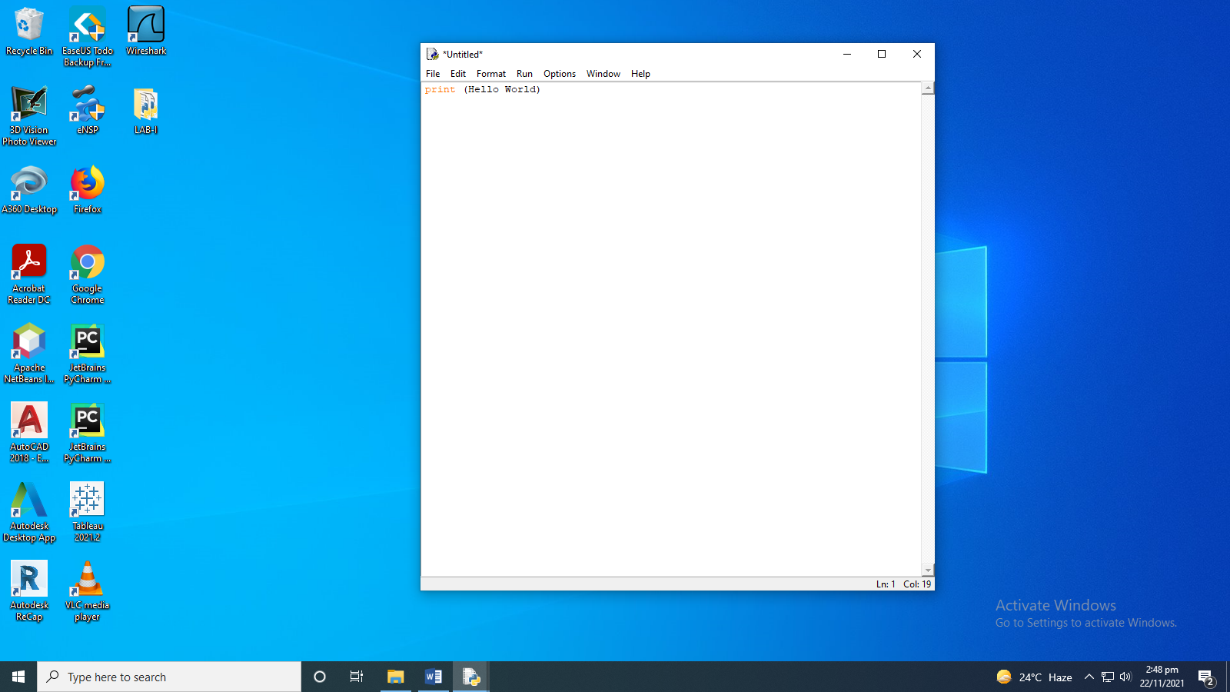

Upon, execution, it gives us the following error, ’Invalid Syntax’, which is different fro, the execution of the code with only one inverted comma.

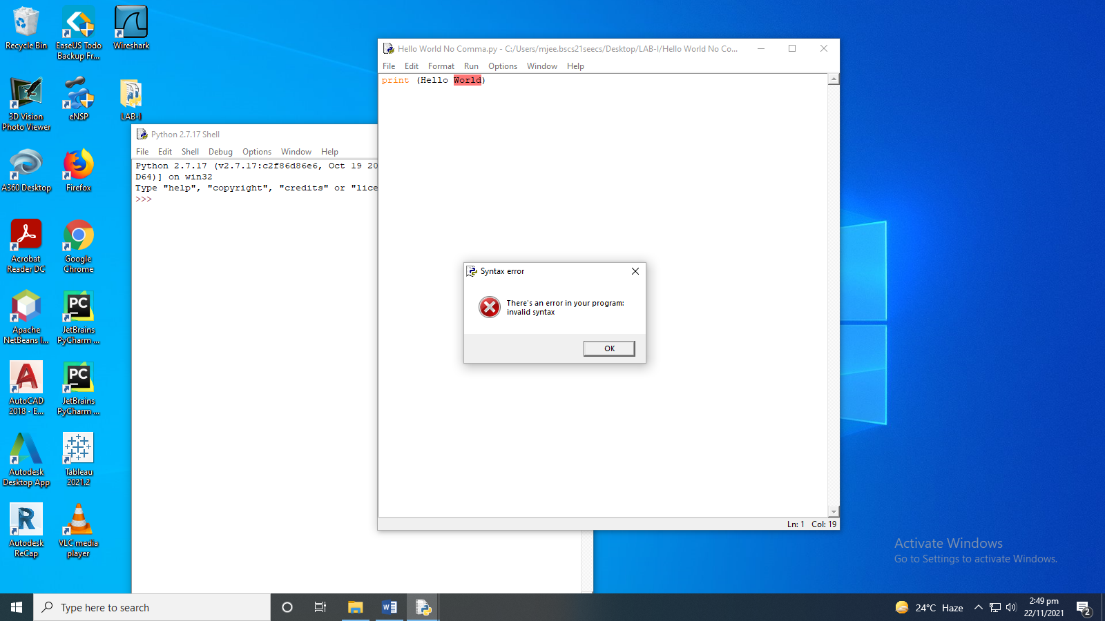

**Task 6) Write a program using one print() command only that produces the following output:**

The code for the following task in scripting mode is as follows.

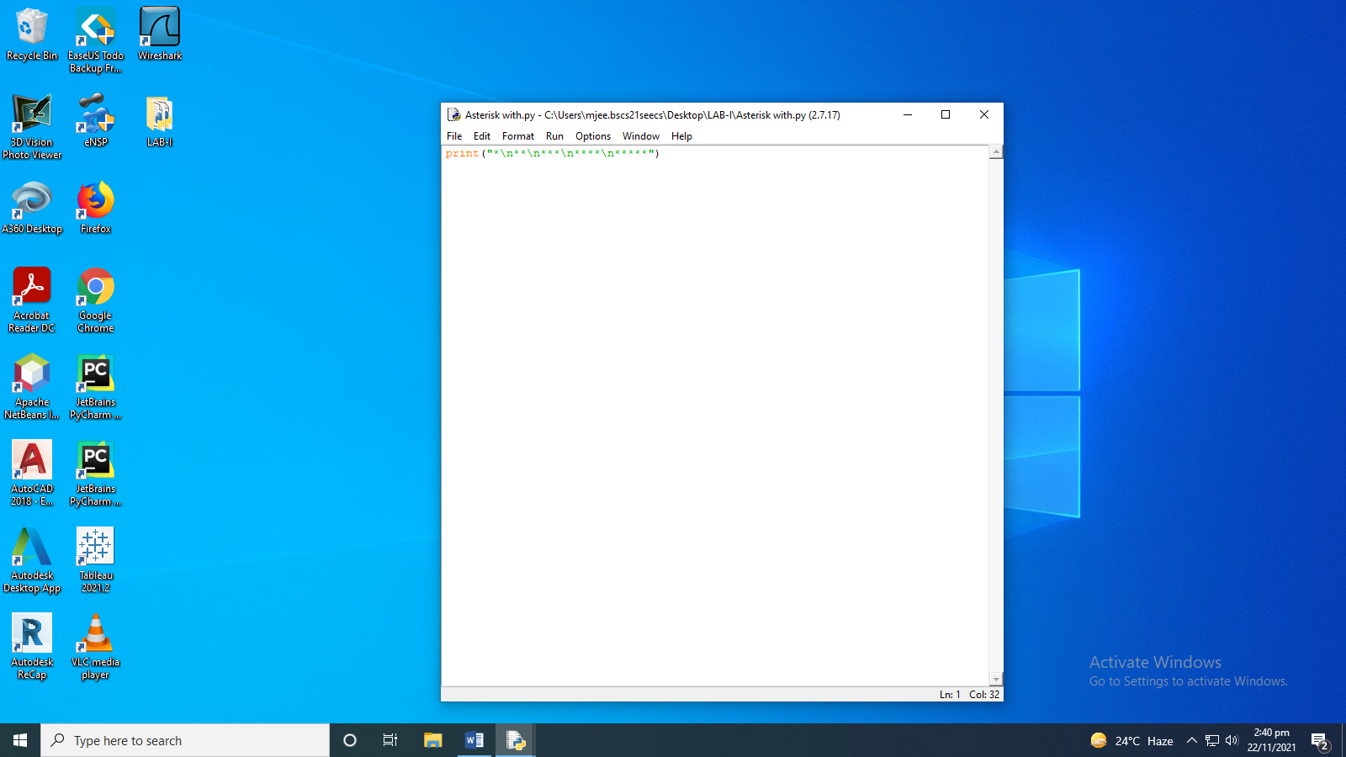

The execution for the Above task is as follows.

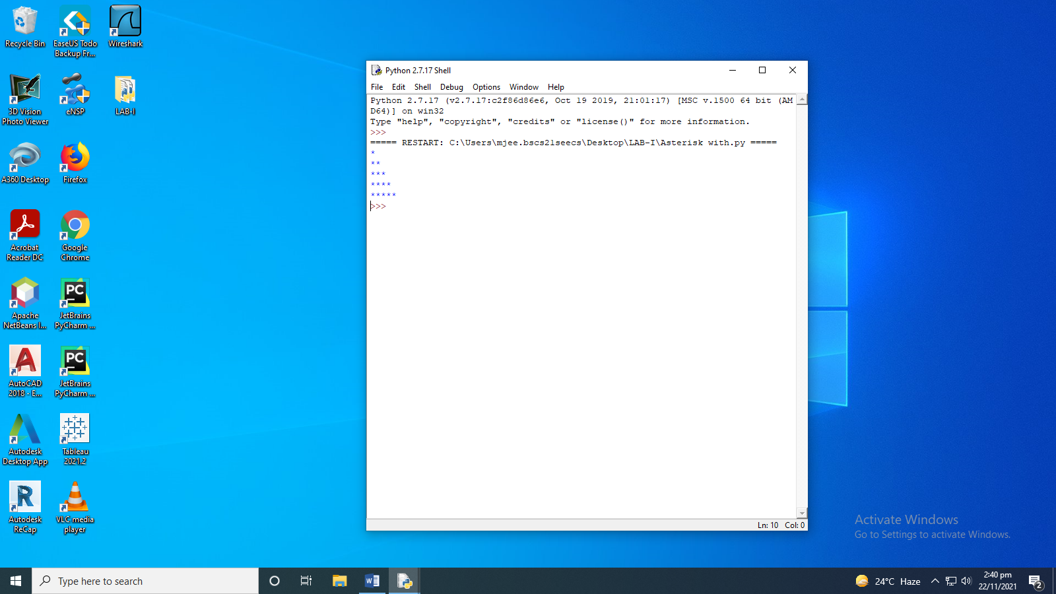

1. **Task 7) Write the above program again but without using any escape sequence within the print () command.**The code for the above task without the escape sequence is as follows.

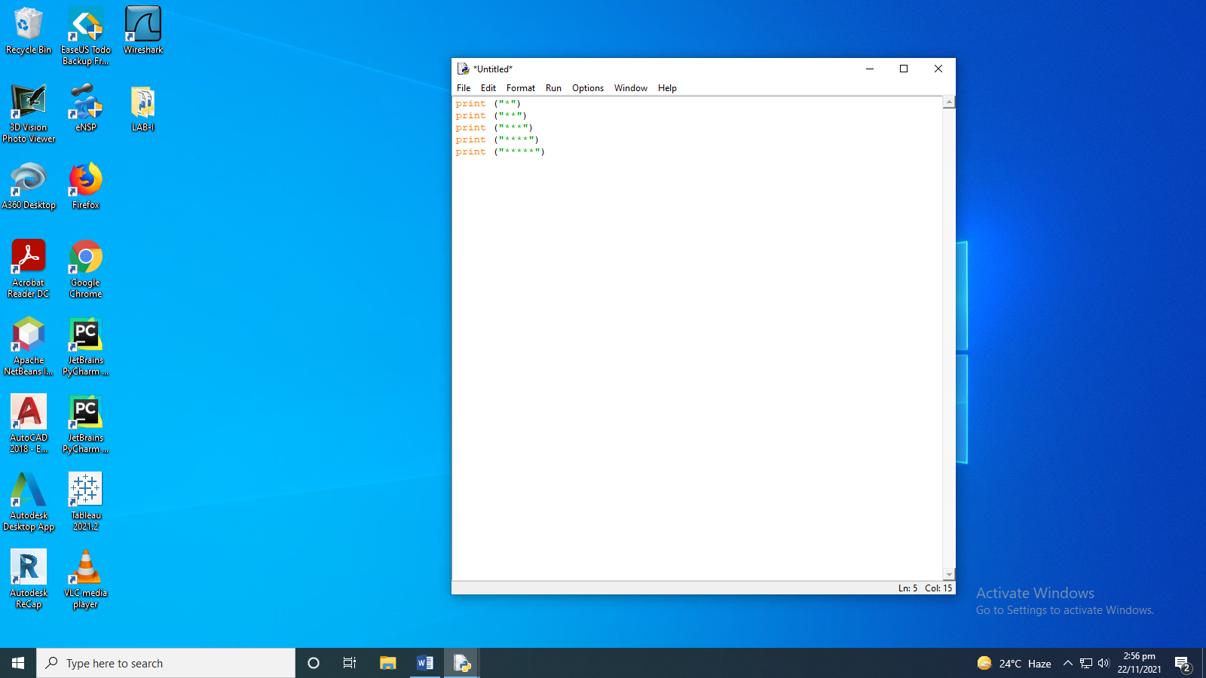

The execution of the above task is as follows.

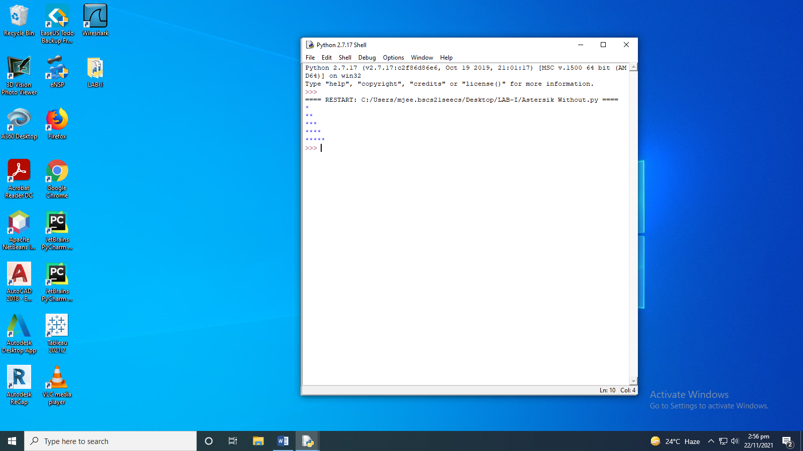

**NAME: MUHAMMAD SHAVAIZ BUTT**

**Worst 7/10**

**PRE-LAB TASKS:**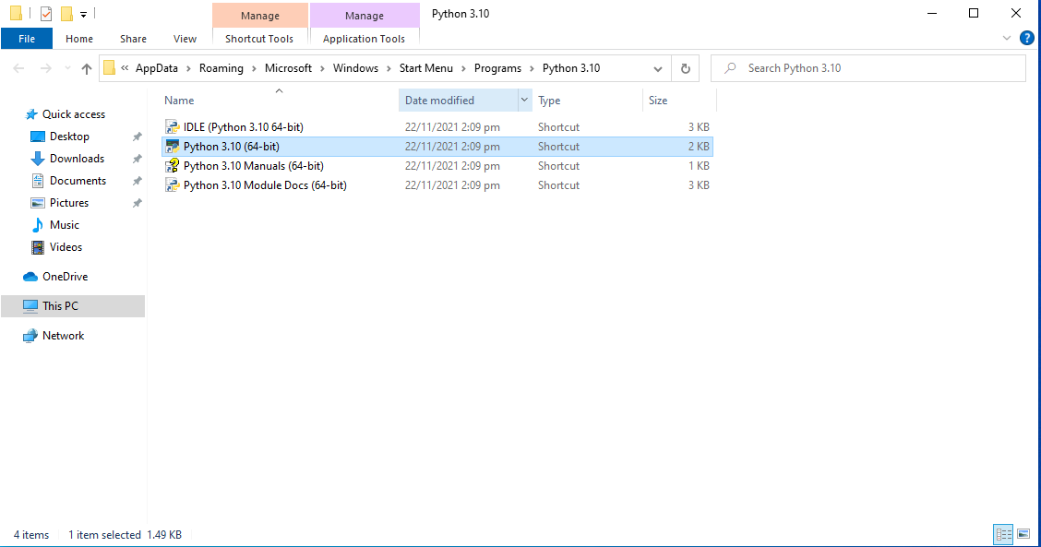

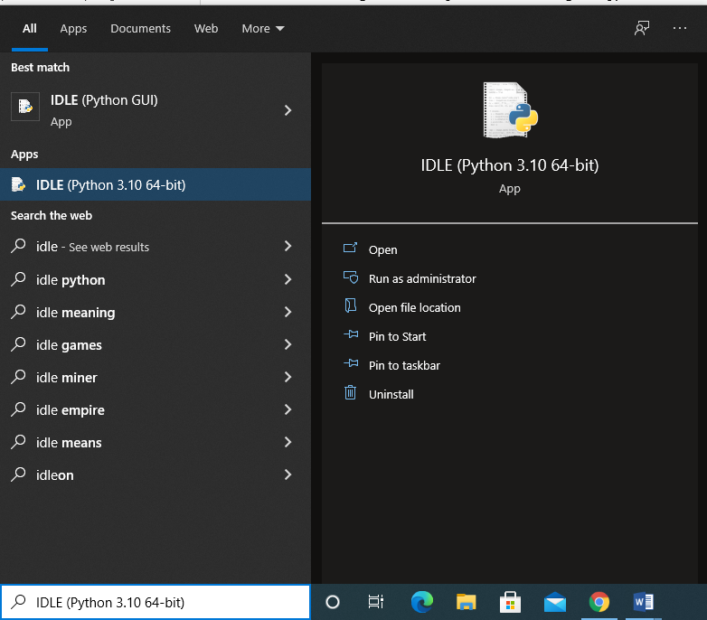

**LAB-TASKS:**

**Interactive mode:** 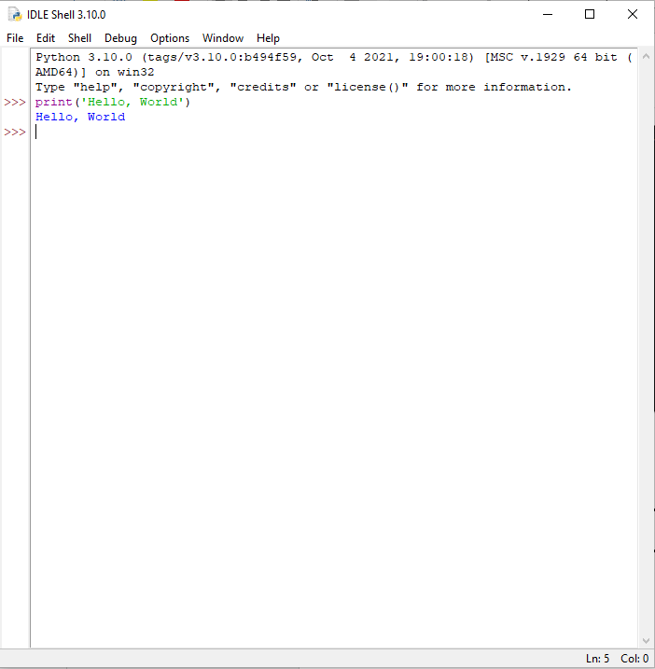

**Scripted mode:**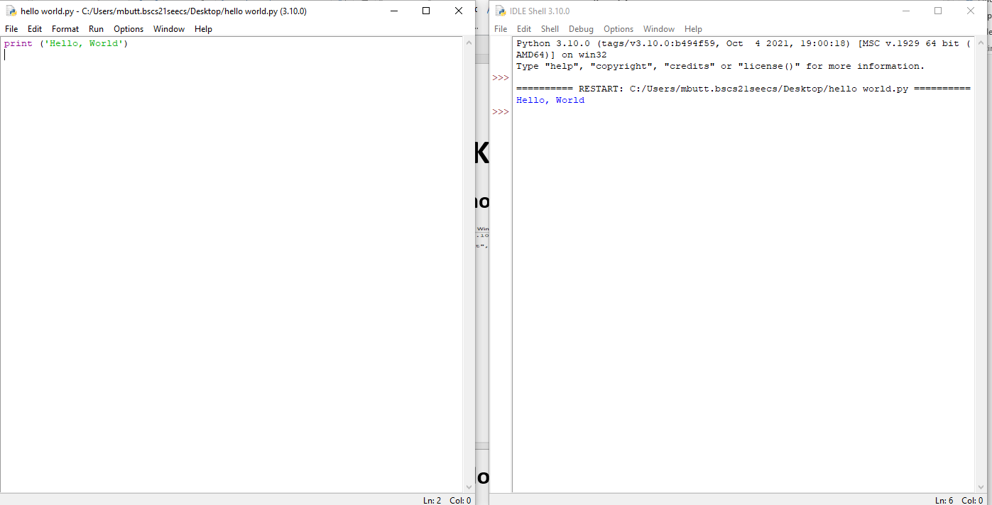

**Removing ending quotation:**

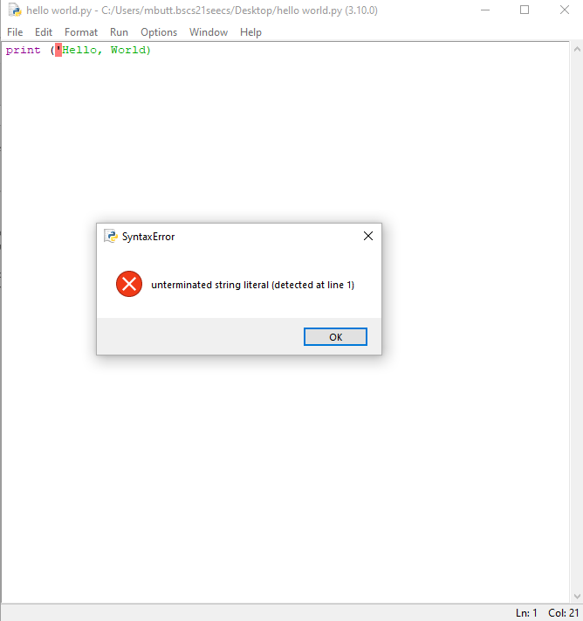

**Removing both quotations:**

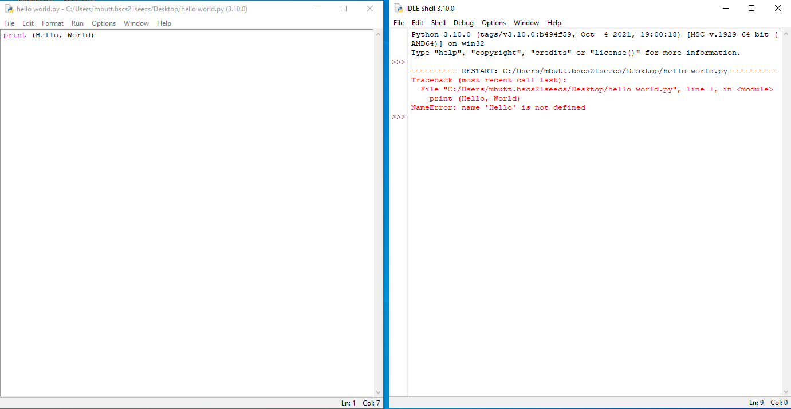

**Output:**

**Output with escape sequence:**

